Purpose
The purpose of this document is to define the Design Control Procedure that will be followed for product development at EPIC.

Scope
This procedure is intended to be used to control the design of new products. This procedure applies to the design and development of any:
- Medical device
- Component, part, or accessory of a medical device.
This procedure is intended to be followed by all personnel who are involved with design and development projects.
Each proposed change to an existing product or process design will be evaluated to ensure that appropriate Design Control Elements are applied to the proposed change.

Definitions
Class I Change | Any change that affects form, fit, or function or that is not interchangeable. This category of change applies to new products and/or changes to the function of the existing products. (Significant changes proposed after initial design is approved need to be considered in context of change control and design control policy.)
Design and Development Plan (DDP) | The guiding plan for the product development that usually consists of elements such as objectives, assumptions, major tasks, milestones, key decision points, resources, responsibilities, contract services, interrelationships between tasks and groups, and identification of major design reviews. The plan is used by the project team to ensure that design activities comply with all internal and external requirements. The plans will identify and describe the interfaces with different groups or activities that provide or result in input to the design and development process.
Design History File (DHF) | A compilation of records which describes the design history of a finished device.
Design Review | A documented, comprehensive, systematic examination of a design to evaluate the adequacy of the design requirements, to evaluate the capability of the design to meet those requirements, and to identify problems.
Design Validation | Establishing by objective evidence that device specifications conform to user needs and intended uses.
Device Master Record (DMR) | A compilation of records containing the procedures and specifications for a finished device.
Process Validation | Establishing by objective evidence that a process consistently produces a result or product meeting its predetermined specifications.
Product Requirements Document (PRD) | A record that documents the physical and performance requirements of a product that are used as a basis for product design.
Requirements | The needs or expectations for a product and/or its software. There can be many different kinds of requirements (e.g., design, functional, implementation, interface, performance, or physical requirements).
Risk Analysis Document (RAD) | A document that identifies, evaluates and prioritizes risks related to product development, product quality, product safety and product changes.
Verification | Confirmation by examination and provision of objective evidence that specified requirements have been fulfilled.
Validation | Confirmation by examination and provision of objective evidence that the particular requirements for a specific intended use can be consistently fulfilled. Also said as, confirmation by examination and provision of objective evidence that software specifications conform to user needs and intended uses, and that the particular requirements implemented through software can be consistently fulfilled.

Design Control Elements
This section identifies the elements that facilitate design control as defined by this Design Control Procedure.

Design Reviews
Formal, documented reviews of the design results will be planned and conducted at appropriate stages of design development.

A review team consists of the individuals who review the design to evaluate the requirements, evaluate the capabilities of the design to meet the requirements, and identify problems. For some Design Reviews, the review team will be the Design Review Board. For other Design Reviews the review team may be the members of the Project Team with direct responsibility for that design stage. Quality Assurance will be represented on all review teams.

A Design Review Package should be assembled by the Project Team and distributed to the review team prior to any Design Review. The package will contain the Design Control Elements to be reviewed and any additional documents or artifacts to aid in the review.

Each Design Review will document meeting minutes which include the following:
- An agenda
- An objective; typically approval to move to the next design stage
- Presentation of contents of the Design Review Package
- Discussion of issues, as appropriate
- Outstanding items and action item assignments, as appropriate
- Conclusions, recommendations, and/or approvals, as appropriate

Action items that do not prevent approval to proceed to the next design stage may be tracked as action items within the design project.

Any outstanding issues will be addressed during the Design Review. Issues may be resolved during the meeting or assignments made to the Project Team to resolve the issues outside the meeting. Minor issues may be addressed and the Design Review Package recirculated at a later time for approval. If major issues are identified, it may be necessary to address the issue and reconvene the review team after resolution.

Any approval to move to the next stage of design will be formally documented. This documentation will include the results of the design review including identification of the reviewed design, the date and the signature of each member of the review team.

The approved Design Review Package and the approval form containing signatures will be placed in the Design History File.

In some instances, a formal meeting may not be required for a Design Review. In these instances, the Design Review Package will be distributed to the members of the review team and could be approved without a formal meeting.

This Design Control Procedure defines a minimum of four Design Reviews which are required. The names of these reviews identify the stage where they occur.
- Product Design Review
- Occurs when Design Inputs are complete and before design begins
- Review team will be the Design Review Board
- Phase Design Review
- Occurs when design of a particular phase is complete and before verification begins
- Review team may be the Project Team
- Phase Release Review
- Occurs when verification is complete and before validation begins
- Review team will be the Design Review Board
- Product Release Review
- Occurs when validation is complete and before Design Transfer to production
- Review team will be the Design Review Board

Other reviews of design or project status may be held as determined by the Project Team. These reviews will be documented and the documentation filed in the Design History File. Guidance for the review team for these reviews will be provided in the project’s Design and Development Plan.

Design Control Statement
The Design Control Statement (DCS) provides a summary of the Design Control Elements that will be employed in the Design Control of a new product or change to an existing product or process. If a Design Control Element (i.e. Product Requirements Document, Risk Analysis Document, Design and Development Plan, Design Verification, Design Validation, Design Transfer, Design History File) is deemed as not applicable, a rationale and justification will be provided in this statement.

Design Inputs
Design Inputs are all the important and critical requirements of a product or plan that addresses the intended use of the product, including the needs of the customer, user, and patient. The Design Inputs for the product include the physical and performance requirements of a product that are used as a basis for product design.
Identifying Design Inputs should include determining the essential and desirable needs of customer, user, and patient. Gathering requirements is more intensive at the start of development of a new product. But it doesn’t end there. It continues through development and validation. The Design Change Control portion of this procedure may be used to capture new or changing requirements and feed those back into design for updated versions of the product.

Product Requirements Document
The Product Requirements Document (PRD) lists out all the requirements necessary for the new product or change to the product or process relating to the needs of the customer, user, and patient. Requirements may include elements such as product functionality, product performance, safety, efficacy, storage; testing, stability, validation, regulatory, biocompatibility, handling, and interfaces of the product with external sources (i.e. companion products, instruments used with the product). This document is intended to clarify and provide specific requirements that are clear and unambiguous.

Initial Risk Analysis Document
The initial Risk Analysis Document (RAD) provides documented evidence of an evaluation of the potential risks associated with the new product or change. The RAD identifies the failure modes that could render the product to become non-efficacious or unsafe for use. This assessment provides a method for measuring the degree of risk associated with the new product design or change. Risk analysis activities will be performed according to a Risk Management Plan.
The initial RAD will be updated as design progresses and the Project Team defines design features and/or processes to mitigate risks. A later version of the RAD will become the final version reviewed and approved before Design Transfer.

Design and Development Plan
The Design and Development Plan (DDP) is a plan that should consist of elements such as objectives, assumptions, major tasks, milestones, key decision points, resources, responsibilities, contract services, interrelationships between tasks and groups, and identification of major design reviews. The plan will be reviewed, updated and approved as the design and development evolves.

Design Input Approval
The Design Approval form documents approval of the Design Inputs by the Design Review Board. Approval of the Design Inputs provides direction for the Project Team to work toward the appropriate product or process design.
Design Input Approval occurs at the Product Design Review when all required Design Inputs are ready and before design work begins.

Design Outputs
Design Outputs are the result of design efforts throughout the total design project. Together the Design Outputs consist of the product, its packaging and labeling, and the Device Master Record. Design Outputs address all the important and critical outcomes from the development process relating to the intended use of the product or changes that could affect the intended use of the product. The Design Outputs may be a combination of the following:

Software Architecture Specification
A Software Architecture Specification provides a summary overview of the components of the software and their interfaces to each other.

Design Specifications
A Design Specification describes in detail how a product will be built to meet the product requirements. There may be multiple design specifications that together fully describe the design of a product. Design specifications for hardware will be different from those for software.

Bill of Materials
A Bill of Materials (BOM) is a list of the raw materials, sub-assemblies, intermediate assemblies, sub-components, parts and the quantities of each needed to manufacture an end product.

Manufacturing Specifications
A Manufacturing Specification defines the process of manufacturing components, sub-assemblies and/or an end product. There may be multiple manufacturing specifications, including work instructions, that together fully describe the manufacturing process.

Traceability Analysis Document
The Traceability Analysis Document (TAD) shows in a summary format that all Design Inputs have been considered and implied obligations met by the Design Outputs. The summary should include references to any appropriate specifications or other documents that show the realization of Design Inputs in the completed product.

Design Verification Protocols
Design Verification Protocols describe all the steps required to perform Design Verification of a component, sub-assembly, or end product. There may be multiple protocols that together will fully verify the product.

Design Validation Protocols
Design Validation Protocols describe all the steps required to perform Design Validation of a particular version of a product. There may be multiple protocols that together will fully validate the product.

Final Risk Analysis Document
The final RAD is an update to the initial RAD that includes objective evidence, through Design Verification and Design Validation, that identified potential risks have been adequately addressed by the product design. The final RAD will include any additional potential risks identified during, or after, design.

Revision History Record
For software projects, the Revision History Record contains a record of every software version submitted for verification and validation. Whenever software is changed, a version will be established prior to the Phase Design Review. Any change required as a result of verification or validation will result in a new version being created. The record will indicate when a version is released to production at Design Transfer.

Design Verification
Design Verification is defined as a confirmation by examination and provision of objective evidence that specified requirements have been fulfilled. Design Verification demonstrates that the Design Outputs meet the Design Inputs. Design Verification may include the testing, experimentation, analysis, and/or evaluations to demonstrate that Design Outputs meet the Design Inputs.
Design Verification will use the Design Verification Protocols to systematically and methodically test/evaluate the product. Results of each verification step will be documented for review. EPIC’s Engineering Studies procedure may be used to document the protocols and/or the report of results.

Design Validation
Design Validation means establishing by objective evidence that the product specifications conform to user needs and intended use(s) of the product. Design Validation also includes testing to defined operating conditions under actual or simulated product conditions.
Design Validation will use the Design Validation Protocols to systematically and methodically validate the product. Results of each validation step will be documented for review. EPIC’s Engineering Studies procedure may be used to document the protocols and/or the report of results.

Process Validation
Process Validation is defined as the establishment by objective evidence that a process consistently produces a result or product, meeting its pre-determined specifications.
Process Validation will use the Process Validation Protocols to systematically and methodically validate the process. Results of each validation step will be documented for review. EPIC’s Engineering Studies procedure may be used to document the protocols and/or the report of results.

Design Output Approval
The Design Approval form documents approval of the Design Outputs by the DRB. Approval indicates that the Design Outputs demonstrate the realization of the Design Inputs in the completed product.
Design Output Approval occurs at the Product Release Review when all design, verification and validation is completed and required Design Outputs are ready for review. This review may include examination and assessment of the following:
- Previously approved Product Requirements Document
- Revised Design and Development Plan
- Final Risk Analysis Document
- Design Verification Protocols and results
- Design Validation Protocols and results
- Traceability Analysis Document
- Any document(s) in the Design History File

Design Transfer
Design Transfer is the official transfer of a new product, change to an existing product, or process into production for commercial use. The transfer process is multi-faceted and occurs throughout the design and development process. However, final Design Transfer activities cannot be completed until after the Product Release Review. Communication (discussions, feedback, reviews, and training) amongst the project team, manufacturing team, and any other groups, should be occurring throughout the development process.

Design History File
The Design History File (DHF) is a compilation of records and documents that describes the design history of the finished product. The DHF will contain or reference all the Design Control Elements required for the development of a new product and/or changes to an existing product or process.

The Project Leader is responsible for reviewing documentation prior to inclusion in the DHF. The DHF will contain all appropriate documentation to ensure that the necessary design controls have been completed and to fully characterize the design project and device development during the life cycle of the design project.

The DHF may be maintained and controlled by the Project Team until final design approval at the Product Release Review. Following the review, during Design Transfer, all DHF documentation will be placed in Document Control and Quality Assurance is responsible for maintaining and controlling the DHF.

The DHF will be compiled throughout the development process and includes records and documents that contain or reference all the Design Control Elements required for the development of a new product or a change to an existing product or process. All the documents outlined in the DCS will be included in the DHF. Once compiled, the DHF will be transferred to Quality Assurance and/or Document Control. Documents that may be transferred as part of the DHF may include:
- Design Control Statement
- Product Requirements Document
- Risk Analysis Document
- Design and Development Plan
- All Design Review documentation
- Other review documentation
- Software Architecture Specification
- Software Design Specifications
- Design Verification protocols and results
- Design Validation protocols and results
- Process Validation protocols and result
- Traceability Analysis
- Revision History Record
- Copies of, or references to, studies, experiments, evaluations, trials, tests, analysis, or other documents that are a part of the development process
- Design Transfer documents and records
- Device Master Record

All DHF documents and records will comply with Document Controls as defined by 21 CFR 820.40.

The DHF will be maintained according to EPIC’s Records Retention and Destruction procedure.

Responsibilities and Approvals
The design and development of products and processes crosses all functional areas of the organization. This section defines the responsibilities of different departments for tasks and approvals.

Design Review Board
The Design Review Board (DRB) is a cross-functional team tasked with reviewing and approving a project as it progresses through the stages of development to ensure the Design Control Procedure is followed and the product satisfies user needs and intended use.

The DRB will perform independent reviews of the new product or process or proposed changes (Class I) to existing product or process design.

The DRB will consist of representative(s) for (as specified in the DDP):
- Manufacturing / Operations
- Quality Assurance
- Regulatory Affairs
- Technical Area (e.g., Engineering)
- Independent Review
- Other Individuals, as appropriate

The DRB will perform the following functions:
- Ensures that Design Inputs are established and approved
- Ensures that Design Outputs meet the approved Design Inputs
- Approves changes to the Design Control Elements or other aspects that affect the design of the product
- Authorizes the design transfer into production

The PRD will be approved by the DRB as revisions occur.

The DRB will initially approve the DDP and initial RAD. Subsequent changes to these two documents will be approved by the DRB or the Project Team.

Project Team
The Project Team is the set of individuals who together collaborate to develop a new product, update an existing product, or modify an existing process.

The Project Team will have a Project Leader. The Project Leader coordinates the work of the Project Team and reports progress and project status to EPIC management.

The Project Team establishes, plans, coordinates, and performs the tasks for producing the Design Control Elements.

The Project Team may approve changes and updates to schedules, plans, risk analysis, and other project related tasks that affect the design project. Changes and updates to schedules, plans, and risk analysis will be approved by the Project Team and will be maintained by the Project Leader. These documents will be included as part of the DHF and will be approved by the DRB at the Product Release Review.

The Project Team will not independently approve changes to the PRD. All changes to the PRD require DRB approval.

Quality Assurance
The Quality Assurance (QA) department ensures that the established quality processes are followed and the outputs of the project meet the needs for internal and regulatory compliance.

QA will have membership on the DRB and should have membership on the Project Team.

QA will ensure (at reviews, during approvals, and through internal audits) that this Design Control Procedure is being followed.

QA will maintain the completed DHF for each new product or process design change once Design Transfer has been completed.

QA will assess new raw material suppliers.

Procedure
This section defines the Design Control Procedure in detail. Refer to Appendix A: for a flowchart of the following procedure.

Product Concept
Every new product begins with an idea. The idea is developed to become a Product Concept. Once the concept is defined, various feasibility studies, market research, and business planning activities will normally follow to ascertain the viability of the product to be developed. Multiple product design alternatives may be considered.
Any existing product not currently under Design Control will be placed under Design Control when a decision is made to further its development. An example of such an existing product would be a product acquired from an outside source with intentions to commercialize it as an EPIC product.

Design Control Elements
Initially, an assessment should be conducted to determine which of the Design Control Elements apply to the Design Control procedure for the project. All the Design Control Elements will apply to a new product. Changes to existing products or process may not require that all elements of Design Control be addressed. Changes to an existing product will be assessed to determine if the changes would be considered a Class I change. This assessment will be conducted and documented in the Design Control Statement.

Design Control Begins
Once the applicable Design Control Elements are known, Design Control begins.

Design Control Statement
The DCS may be included in the DDP or it may be a separate, standalone document. If separate from the DDP, it will be approved and included in the Design History File.

Product Requirements Document
A PRD will be written based on the feasibility studies, market research, and business needs identified while developing the Product Concept. These requirements need to be verifiable and able to be validated as appropriate. The PRD is intended to provide fairly specific requirements that can include:
- Intended Use
- Description
- Product characteristics, e.g. physical, mechanical, safety
- End-user requirements
- Product functional characteristics
- Regulatory requirements
- Manufacturing requirements
- Methods requirements
- Test/release requirements
- Packaging and labeling requirements
- Storage and handling requirements
- Shelf life requirements
- Shipping/transportation requirements
- Servicing/replacement requirements
NOTE: Initially, the PRD may not be complete in all necessary areas. As more information becomes available, it may be modified, added to, and expanded.
After the initial PRD is approved, the subsequent revisions will track changes and be approved by the DRB.

Initial Risk Analysis
Initial Risk Analysis of the product or process will be conducted. A Risk Management Plan and an initial RAD will be produced. Using the defined requirements and design alternatives, potential hazardous events/failures and their causes will be identified and itemized. For each event/failure, severity will be determined and methods for control and corrective measures defined. EPIC’s Risk Management procedure will be used to guide this risk analysis assessment.

Design and Development Plan
A DDP will be prepared to ensure that the design process is appropriately defined and controlled.

The plan will consist of elements such as goals/objectives, assumptions, major tasks, deliverables, milestones, key decision points, resources, responsibilities, contract services, and interrelationship between tasks and groups. The plan will include the identification of the Design Reviews required at various stages of the project.

The DDP will include information on the key Design Control Elements such as Design Inputs, Design Input Approvals, Design Outputs, Design Output Approvals, and Design Transfer.
NOTE: Initially, the DDP and initial RAD may not be complete in all necessary areas. As more information and analysis becomes available, they may be modified, added to, deleted from, and expanded. After the initial versions are approved, substantial changes to the plan will be reviewed and approved by the DRB.

Product Design Review
When the appropriate Design Inputs have been completed, a Product Design Review will be conducted.

The Design Review Package for the Product Design Review will include:
- Design Control Statement
- Product Requirements Document
- Initial Risk Analysis Document
- Design and Development Plan

The Product Design Review will be conducted as defined above in the Design Reviews section.

The objective of the Product Design Review is to provide approval to begin the Design stage.

Design Phases
Once the Design Inputs have been approved, multiple phase(s) for development, verification and validation can be initiated. Each phase consists of design, construction, and verification, with appropriate reviews and results in a version of the product. In some instances, a single phase may be all that is required.

Hardware Design
The design and construction process for hardware will be different from that of software. This section defines the hardware detailed design process.

Development results in the generation of production specifications as well as descriptive materials which define and characterize the design.

The Project Leader creates the design specifications as part of documenting design outputs and should include or reference all the relevant information required to manufacture, operate, maintain and market the device in accordance with its intended use and may refer to other device documentation including user manuals and assembly instructions.

The Project Leader collates the Design Outputs into a TAD. The design development process continues until all required inputs are met. The Project Leader is responsible for updating the TAD as the project progresses and the verification and validation activities demonstrate that the outputs satisfy the inputs.

Design reviews should be conducted where appropriate to support the design control activities. Refer to Section E of FDA’s Design Control Guidance for Medical Device Manufacturers.

Software Design
The design and construction process for software will be different from that of hardware. This section defines the software design process which includes construction (implementation/writing of software source code).

Each phase begins with investigation and planning for the phase. The Project Team will analyze the objectives for the phase and investigate methods for design and implementation of the tasks to meet the objectives. This may involve considering different designs and/or creating prototypes to investigate alternatives.

When investigation is complete and the Project Team has determined the design approach to be used, a Phase Plan will be created by the Project Leader. The Phase Plan will include all the tasks necessary to complete the phase and will be used to track progress. The Phase Plan should be reviewed and approved by the Project Team.

The Project Team will begin design tasks once investigation is complete. Design may begin in parallel to creation of the Phase Plan. During design, the team will document the design of the features and functionality to be implemented in the current phase.

During the first phase no specifications will exist. The development team will determine which specifications are required and will create the initial versions. In following phases the existing specifications may be updated to create newer versions or new specifications may be created as appropriate.

A Software Architecture Specification will be created, or the existing one revised, as necessary.

Software Design Specifications will be created, or the existing ones revised, as necessary. These specifications provide details about the design of the various software components. The Software Design Specification(s) may be distributed among multiple documents based on functional area, or as the Project Team determines, to allow parallel design efforts or to keep documents to manageable size.

A TAD will be created (or the current one revised) to map Design Inputs to Design Outputs.

When design tasks are complete and design specifications updated, a Software Design Evaluation may be conducted. If the design changes are complex, an evaluation should be performed. This evaluation is a review by the Project Team to assure their collective efforts have produced a design that meets the requirements and the objectives of the phase.

Minor issues may be addressed during the evaluation. Major issues may require changes to the design and a follow-up meeting to evaluate the changes.

The Phase Plan should be updated if any additional work affects scheduled milestones.

After the Project Team has evaluated the software design, Software Construction will begin. During this stage, the software design will be realized as working software code.

At the end of Software Construction, the Project Team will revise Software Design Specifications, the TAD, and the RAD, as appropriate. Updates to the RAD include corrective measures included in design and construction to eliminate, reduce, or warn about potential hazardous events. The key requirement is that the Project Team review the specifications, TAD, and RAD to be sure they are current with the design and implementation.

The Revision History Record will be updated to assign a new version to the software.

When the design for the phase is complete and documented, a Phase Design Review will be held.

The Design Review Package for the Phase Design Review will include the following:
- Design specifications produced by the Project Team
- Revised Risk Analysis Document
- Traceability Analysis Document
- For hardware:
- Current Design Master Record
- Manufacturing Specifications
- Work Instructions
- Bill of Materials
- For software:
- Software Architecture Specification
- Revision History Record, initial version

The Phase Design Review will be conducted as defined above in the Design Reviews section.

The objective of the Phase Design Review is to provide approval to begin Design Verification activities.

Following approval of the design at the Phase Design Review, Design Verification will commence. Design Verification may include the testing, experimentation, analysis, calculations, and/or evaluations as a confirmation that Design Outputs meet the Design Inputs. Examples of Design Verification include:
- Evaluation of performance, stability, safety, reliability of the product, or process under expected operational and storage conditions
- Inspections to verify that all design features are as intended and that design changes are identified and accomplished
- Biocompatibility testing of materials, as applicable
- Bioburden/safety testing, as applicable
- Measurements and/or dimensional analysis, as applicable
- Analytical testing and analysis, as applicable
- Equivalency testing to a design having a history of successful use, as applicable
- Identification of critical process control parameters and specifications, as applicable
- Identification of material specifications and qualification of raw materials, as applicable
- Package integrity testing, as applicable
- Literature search/scientific literature
- Execution of software unit tests and analysis of results
- Execution of software verification protocols and analysis of results

When Design Verification is complete, a Phase Release Review will be held prior to releasing the current product version for Design Validation.

The Design Review Package for the Phase Release Review includes the following:
- Revised design specifications (if applicable)
- Verification protocols and documented results
- Evidence of all other verification activities and results
- Revision History Record, final version (if applicable)

The Phase Release Review will be conducted as defined above in the Design Reviews section.

The goal of the Phase Release Review is approval to begin Validation. Any outstanding issues will be resolved before approval is provided.

Validation
Design Validation is a cumulative summation of all efforts to assure that the product design will conform to the user/customer needs and intended use.

Design Validation will target the use of the product in the actual or simulated environment, where possible. Examples of Design Validation include:
- Clinical trials/clinical evaluation
- End-user handling studies
- Actual or simulated-use environment tests
- Compilation of relevant scientific literature or provision of historical evidence

Process Validation activities are a cumulative summation of all efforts to assure the processes will conform to pre-determined requirements in the actual operating environment. These validation activities are intended to demonstrate that equipment, facilities, manufacturing processes, and test methods perform as required. Process Validation activities include:
- Installation Qualifications (IQ)
- Operational Qualifications (OQ)
- Performance Qualifications (PQ) such as:
- Aseptic processes
- Sterilization dose audits
- Software validations
- Process validations

Supplier qualification will be performed according to the appropriate SOP.

Final Risk Analysis
A final Risk Analysis of the product or process will be conducted. Using the current, approved RAD, an assessment will be performed to determine if the risks in the RAD were mitigated through Design Verification and Validation. The failure modes, effects of a failure, cause of the failure, and actual process controls will be reassessed. The actual severity, occurrence, and detection of failure will be evaluated. Based on this assessment, risk of failure can be assigned to product design or process aspects. It is intended that the Design Verification and Validation efforts significantly reduce the potential risk of product or process failures.

Product Release Review
Once Validation and the final RAD have been completed, a Product Release Review will be held. This is the final review prior to Design Transfer to manufacturing.

The Design Review Package for the Product Release Review includes the following:
- Evidence of all Validation activities and results
- Final Risk Analysis Document
- Final DHF review for compliance to internal and external requirements. This review may be performed and documented for review at the Product Release Review or it may be performed at the Product Release Review and documented in the design review minutes.

The Product Release Review will be conducted as defined above in the Design Reviews section.

The objective of the Product Release Review is to provide approval to finalize Design Transfer activities. Any outstanding issues will be resolved before approval is provided.

Design Transfer
Design Transfer is the bridging phase between design/development and product manufacturing. It is a transfer of knowledge in the form of training, documentation, and know-how. This phase ensures that the Design Outputs are correctly translated into production documentation. Design Transfer may include:

Training of Manufacturing and Quality Control employees and others to whom the transfer is occurring.

Transfer of data and documentation for the manufacturing and testing of the product. This documentation may include the following where applicable:
- Bill of Materials (BOM)
- Component specifications including material, tolerances, dimensions, and finishing details
- Work instructions including tolerances for critical interfaces
- Calibration procedures
- Device specifications (including limits of accuracy of measuring functions)
- Instructions for use
- Incoming inspection specifications and procedures
- Electronic data files
- Software installation package
- Software installation instructions
- Final inspection check list or procedure
- Packaging and Labeling
- Safety certification documentation
- ESD/EMI/EMC certification documentation
- Risk analysis documentation
- Packaging test report

Preparation of a Device Master Record including all the documents required to manufacture a product. The Device Master Record is reviewed and approved prior to final design transfer. Follow EPIC’s Device Master Record procedure.

Transfer the DHF to QA.

Verification that design specifications released to production have been approved, verified, and/or validated before they are implemented as part of the manufacturing process.

Design Change Control
The need for change can occur during any stage of the design process, from requirements definition to Design Transfer. Change may be required due to errors in design, either hardware or software, or in processes. Other sources of change are enhancements, discovery of better design alternatives, or better parts come to market. These are just examples.
Change will be managed using a systematic, controlled procedure. Some changes may be minor and the Project Team may decide to implement those changes during the Design phase. More significant changes, particularly those that may affect requirements and/or risk will be reviewed. The following Design Change Control procedure is a subset of the overall Design Control Procedure. It defines how EPIC will control changes while a product or project is under Design Control. It does not address changes to products that have been released to the marketplace.

Changes That Need Review

Any change that affects one or more requirements after the PRD has been approved by the DRB at the Product Design Review.

Any change required due to a discovery during a Design Phase that the Project Leader decides is outside the scope of the work defined for that phase.

Any change required due to a discovery during Design Validation or Process Validation. At this point the Design Phase being validated is complete and has been approved by the DRB at the Phase Release Review. Thus, any change requires DRB approval.

Any change required during Design Transfer. Changes required at this stage are changes to a product that has received final approval by the DRB at the Product Release Review.

Changes That Do Not Need Review

Any change authorized by the DRB during a Design Review. The DRB has final review and approval authority so a change authorized by the DRB will be deemed approved.

Any change due to discovery during the Design stage that is within the scope of the current Design Phase. The Project Leader has discretion to determine what is within the scope.

Any minor change due to discovery during the Design stage.

Design Change Capture
Systematic change control requires that the need and reasons for each change be documented and captured as a Design Change Request. All changes require a Design Change Request, with the following exceptions:

Any change within the scope of the current Design Phase.

Any change not affecting form, fit, or function of the device or software. For example, in software, updates to internal code comments or changes to names of variables, functions, or modules do not require a Design Change Request.
The set of Design Change Requests for a project will be organized and maintained by the Project Leader. A software system, such as a “bug database,” may be used for this purpose and Design Change Requests may be submitted electronically.

Design Change Review
The current set of Design Change Requests will be reviewed, at appropriate times, and used to define the work for a Design Phase.

The review team for design changes may be the DRB or it may be another team designated specifically for this purpose. Minimally, the team should include at least one member from the project team, QA, and executive management.

The review team will review the set of outstanding Design Change Requests and choose a subset to define the work for a Design Phase.

The review team will determine if any Design Change Request that is part of the Design Phase is a change in requirements. If a change in requirements is necessary, the project team will be tasked with updating the PRD. Once the PRD is updated, a Product Design Review will be held to review the changes and gain approval from the DRB. If the Design Change Request does not require a change in requirements, the project team may begin the new Design Phase immediately.

Any approval for a Design Phase will be formally documented. This documentation will include a list of changes to be included in the Design Phase, identification of requirements changes, if any, and the dated signature of each member of the review team. This documentation will be placed in the DHF.

Hardware/Software Specifics
The specific procedure, and related documentation, for hardware design changes is different for the specific procedure, and related documentation, for software design changes.

The procedure for hardware design change is defined by EG-007, Design Changes. A Design Change Request may be documented using EGF-010, Design Change Request, or any form that satisfies the procedure defined by EG-007.

The procedure for software design change is defined by EG-021, Software Change Control Procedure. A Design Change Request for software is a Software Change Request as defined by EG-021.

End Design Control
The Design Control Process ends at this point.

Post Market Surveillance
Over time, changes, or improvements to the product or production processes may be required. Feedback from users/customers, manufacturing, or other groups may be obtained. Based on the feedback, design changes may be required. The proposed changes can be considered and should be evaluated within the Design Control program as applicable.

References
21 CFR 820.30 | Design Controls, Quality System Regulations for Medical Devices
21 CFR 820.40 | Document Controls, Quality System Regulations for Medical Devices
ISO13485 | Quality System – Medical Devices – particular requirements for the application of ISO 9001
 | Design Control Guidance for Medical Device Manufacturers (FDA)
EG-007 | Design Changes Procedure
EG-012 | Risk Management
EG-013 | Device Master Record
EG-020 | Engineering Studies
EG-021 | Software Change Control Procedure
EGF-001 | Design Approval Form
EGF-002 | Traceability Analysis Form
EGF-003 | Design Review Minutes Form
EGF-010 | Design Change Request
EGF-012 | Design Development Plan (DDP)
OPS-008 | Supplier Qualification
OPS-010 | Records Retention and Destruction
- Development Procedure Flowchart
This appendix provides a graphical representation of the Design Control Procedure as a flowchart.
- Core Procedure
The core procedure is shown in the following flowchart. The core procedure is the same for hardware and software. The Design step is different and the specifics are shown in the following sections.
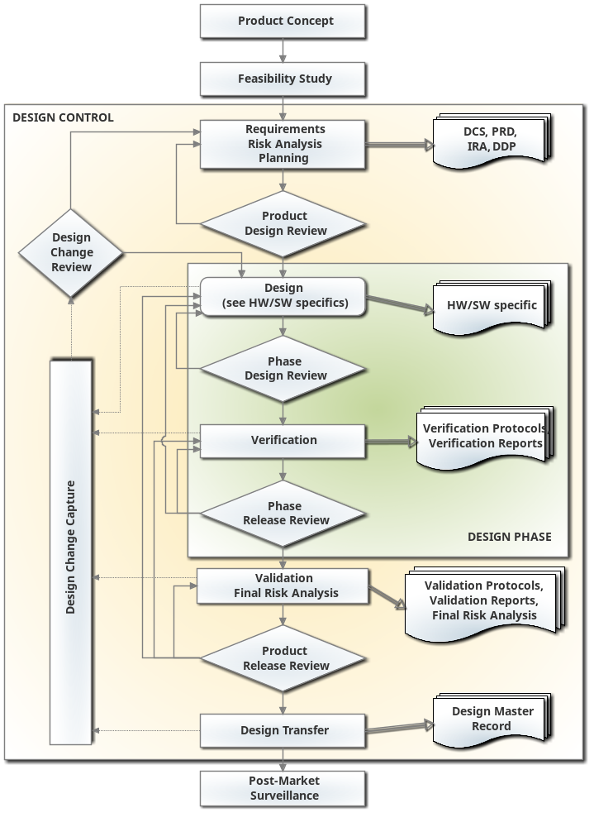
The steps of the procedure framed by the larger orange-colored box (lighter box without color) are the steps under design control. The steps of the procedure framed by the smaller green-colored box (darker box without colors) are the steps of a Design Phase.
The main flow of the design/development procedure is down the middle, top to bottom. On the right side of the diagram are outputs from different stages in the procedure. Any output can be an input used in a later stage. On the left side is Design Change Control. The need for change can be discovered during most stages of the procedure. Change Requests are captured and then reviewed at appropriate times.
The solid arrows show flow from one stage or decision point to another. The double arrows show outputs. The dashed arrows indicate where the need for change can be discovered and the result being change capture.
- Hardware Specifics
The Design stage for hardware development, at the beginning of any Design Phase, is one of Detail Design. During this stage, designers iterate through design alternatives, creating and testing prototypes, and documenting the design in detail so it can be transitioned to manufacturing for production.
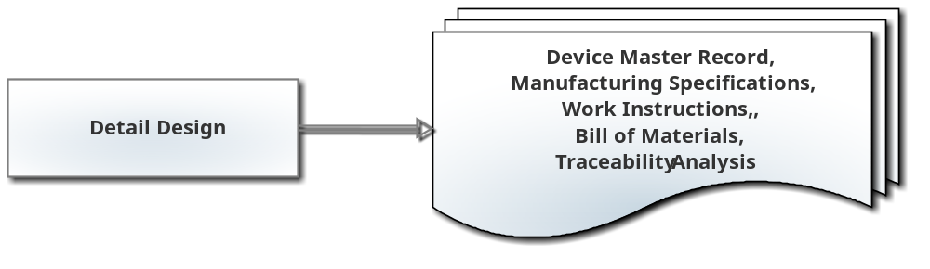
- Software Specifics
The Design stage for software development, at the beginning of any Design Phase, is a multi-step procedure. It starts with investigation, finding design alternatives and creating prototypes. When the Project Team determines the design to be used, they begin Software Design. When the design for the phase is complete, a Software Design Evaluation may be held to review the design before starting Software Construction. Once the Project Team has accepted a design, Software Construction begins. Design specifications are created or updated during Software Design and revised as appropriate during Software Construction.
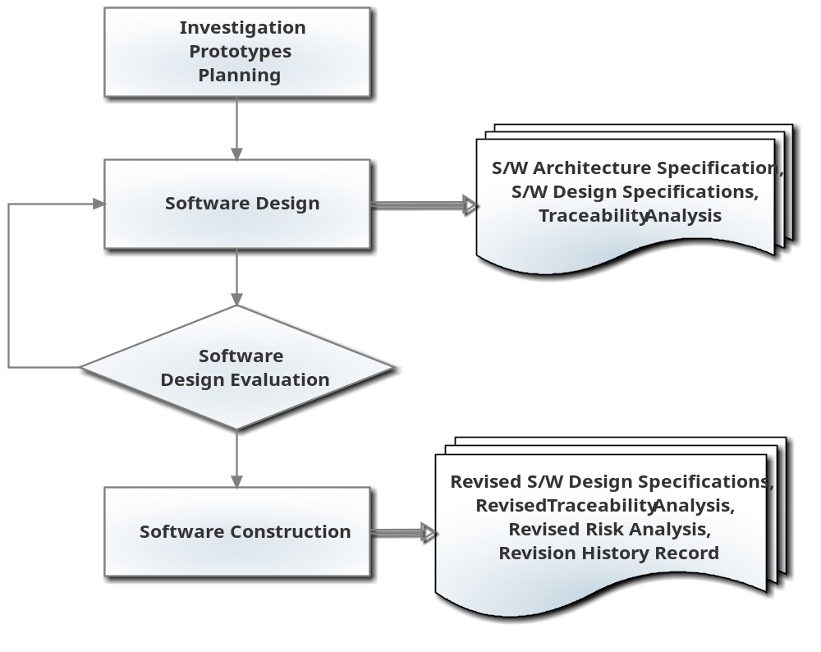
Document Revision History
Change Order | Version | Description of Change | Date | Updated by
CC-052709-01 | 000 | New Document | 05/27/09 | TJ
CC-100809-01 | 001 | Update section 4.0 to reflect accurate responsibilities. Update section 7.0 to new format. Correct grammar/typographical errors throughout. | 10/08/09 | AM
CC-120601-01 | 002 | Complete rewrite of the entire procedure to combine the design control process into one comprehensive SOP. The title of the document was changed from Design Control Policy to Design Control Procedure. | 6/12/12 | A. Miller
CC-120717-01 | 003 | Removed “Technical Area” from “Independent Review” representative in section 4.1.2, minor wording change in section 7.7 for clarity, and added “Process” to section 7.13 for clarity. | 7/25/12 | S. Pletzer
CC-130319-02 | 004 | Completely rewritten to define Design Phases and incorporate software specific procedures previously specified in EG-010. Obsoletes:  - EG-010 Software Development  - EG-018 Software Development Lifecycle | 3/21/13 | L. Kurth

